|  |  |
| --- | --- |
| Ben Vernasco and Brandt Ryder  Ph.D. Research Ecologist  Migratory Bird Center  Smithsonian Conservation Biology Institute  National Zoological Park  Box 37012, MRC 5503  Washington DC 20013-7012 | Tobie GETTI 969 rue de la Chavanne  73490 LA RAVOIRE  FRANCE  [tobiegetti@hotmail.fr](mailto:tobiegetti@hotmail.fr)  (0033)6 51 62 91 19 |

La Ravoire, France, 21th of August 2017

Subject: Manakin bander

Dears Mr Ben Vernasco and Brandt Ryder,

I am writing in application for the Manakin bander position at the Tiputini Biodiversity Station advertised on the Ornithology Exchange website.

During my three years studying for my bachelor degree at Université Savoie-Mont-Blanc (France), I had the opportunity to improve a lot my theoretical knowledge in biology and ecology fields. In addition, I also worked on the field for several projects during my summer time. In 2016 I went in Kouchibouguac National Park (NB, Canada) to work on a monitoring project about River Otter (*Lontra canadensis*), where I was supervised by Nicolas LECOMTE from Moncton University (NB, Canada). And more recently, from May to July 2017 I work for the Alpine Marmot Project field in the Parc National de la Vanoise which is a protected area in the French Alps in which a population of alpine marmots (*Mamota marmota*) is followed since 30 years. I took part of this long-term capture-mark-recapture study as a research assistant, handling and processing the individuals (biometric measurements, biologic samples, behavioral observations,.. ), as well as handling several electronic gears in this remote area.

Recently Bachelor degree graduated, I’m a filed biologist with strong naturalist background, and I chose to book next year to practice on the field to enrich even more my skills. I will first go to St-Lawrence River banks to band passerines and owls from 15th of September to 6th of November 2017, after having banded passerines in France for several weeks. These experiments in banding will allow me to be rapidly efficient in Tiputini.

For these reasons I would really enjoy to come at the Tiputini Biodiversity Station as Manakin bander, from mid-November and as long you need me. Your offer would give me the opportunity to apply my knowledge in conservation.

The position of Manakin bander with the Migratory Bird Center attracts me because I really want to work usefully and to my point of view understanding natural phenomenon is the beginning point to protect them in an appropriate way. Therefore, this position would give me a chance to use my skills for a meaningful project. Additionally I am convinced that to work in a foreign organization will be formative for me, and will contribute to develop my adaptation abilities.

I thank you for your attention and hope that my profile if fulfilling your requirements, welcoming the opportunity to discuss more about your project.

I’m looking forward to hearing from you.

Yours sincerely,

Tobie GETTI

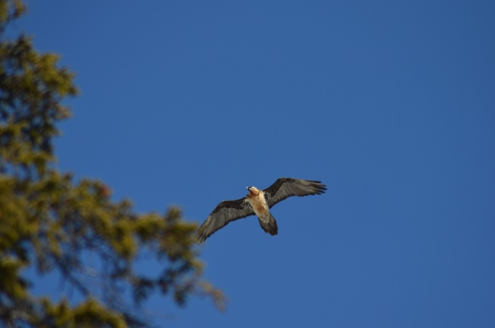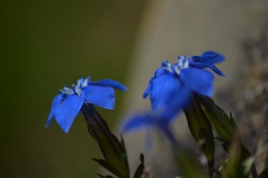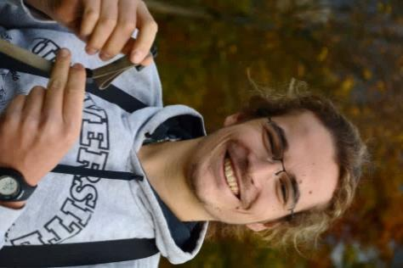

|  |  |  |
| --- | --- | --- |
| **Tobie GETTI**   969 rue de la Chavanne  73490 LA RAVOIRE  FRANCE  Tél : 00336.51.62.91.19  Email : tobiegetti@hotmail.fr | H:\Photos\Flore\Sabot de Vénus\DSC_0597.JPGH:\Photos\Faune\Mammifères\Hermine\DSC_0874.JPGH:\Photos\Faune\Amphibiens\Grenouille rousse\DSC_0507.JPG | French 22 years old  Driving license holder PSC1 (first aid diploma)  Hunting license holder |

**MANAKIN BANDER**

|  |
| --- |
| **WORK EXPERIENCE** |

**15/05/2017- LBBE (Laboratory of Biometrics and Evolutionary Biology) , University of Lyon 15/07/2017 (France) – Volontary placement**

Fieldwork for the Alpine Marmot (Marmota marmota) Project : capture using several types of traps, handling, biometrics measuring, database using, electronic gears using

**07/06/2016 - Biology department, University of Moncton (New-Brunswick, Canada)**

**31/07/2016 – Volontary placement**

Summer monitoring of river otter (*Lontra canadensis*) in Kouchibouguac National Park

area: prospection, manipulation of automatic cameras, collecting traces of presence

**14/10/2014 - Vietnam**

**05/11/2014** Identification of hiking trails on high plateaux near Kontum and realization of a trail guidebook for local guides

|  |
| --- |
| **Education** |

|  |  |
| --- | --- |
| **2013- 2015**  **2015-2017** | **Agricol highschool – Lycée Olivier de Serres, Aubenas (France)**  - BTSA GPN : two years postgraduate diploma in nature management and protection  - BPJEPS « Activités de la randonnée » : diploma to manage groups in trekking trips on easy terrain  - Specific training in moving about on ropes to undertake inventories of vertical natural environments  **University of Savoie Mont-Blanc (France)**  - Bachelor in Life Science, majoring in Biology-Ecology in Mountain Environments, with some courses about geology and geography: diverse monitoring methods, treatment of databases, using of several software including R |

|  |
| --- |
| **LANGUAGES** |

|  |  |
| --- | --- |
| **English**  **Spanish** | Read and spoken  Conversational |

|  |
| --- |
| **Hobbies** |

|  |
| --- |
| **Sports**  **Miscellaneous** |

Ski touring, running, hiking, cycling

Wildlife photography, nature watching, travelling **Societies**  -Volunteer with the LPO (Bird Society) and FRAPNA (Regional federation for nature protection)

- BAFA holder (diploma to manage children groups) - Scouts: - Group leader for the past 3 years, able to manage summer camps

- Organisation for two years, then realization of a solidarity project in Mongolia

during summer 2014

**Contacts for professional references**

- Nicolas Lecomte, Canada Research Chair older in Polar and Boreal Ecology. nicolas.lecomte@umoncton.ca. 001-506-858-4291

🡪 Work placement supervisor during summer 2016 in Kouchibouguac National Park, monitoring River Otter (*Lontra canadensis*)

- Eric Tremblay, Park Ecologist, Northern New Brunswick Field Unit, Parks Canada. eric.tremblay@pc.gc.ca. 001-506-876-1210

🡪 Work placement supervisor during summer 2016 in Kouchibouguac National Park, monitoring River Otter (*Lontra canadensis*)

- Daniel Gallant, Resource Management Officer, Northern New Brunswick Field Unit, Parks Canada. daniel.gallant@pc.gc.ca. 001-506-876-1229

🡪Work placement supervisor during summer 2016 in Kouchibouguac National Park, monitoring River Otter (*Lontra canadensis*)

- Sylvia Pardonnet, Field Technician, LBBE (Laboratory of Biometric and Evolutionnary Biology). [sylvia.pardonnet@univ-lyon1.fr](mailto:sylvia.pardonnet@univ-lyon1.fr). 00334 72 44 85 83

🡪Work placement supervisor during summer 2017 on Alpine Marmot Project, monitoring Alpine Marmot (*Marmota marmota*)